1. Introduction

1.1 overview

The project tittle is **Measuring the pulse of prosperity: An index of economic freedom analysis.** An index of economic freedom compares the jurisdictions against each other for various aspects, from that aspects we shows the 2022 economic freedom scores, index score of financial freedom,population and unemployment, top ranking countries and bottom ranking countries, top 40 countries of GDP growth rate, correlation between inflation and unemployment, GDP and monetary freedom, inflation rate in different countries, 5 years GDP growth rate.

* 1. Purpose

An index of economic freedom measures and ranks countries according to relevant standard and the main purpose is to measure the economic freedom of nations around the world. From this project we can find the individual countries growth rate and economical freedom.

1. Problem definition and design thinking
   1. Empathy map

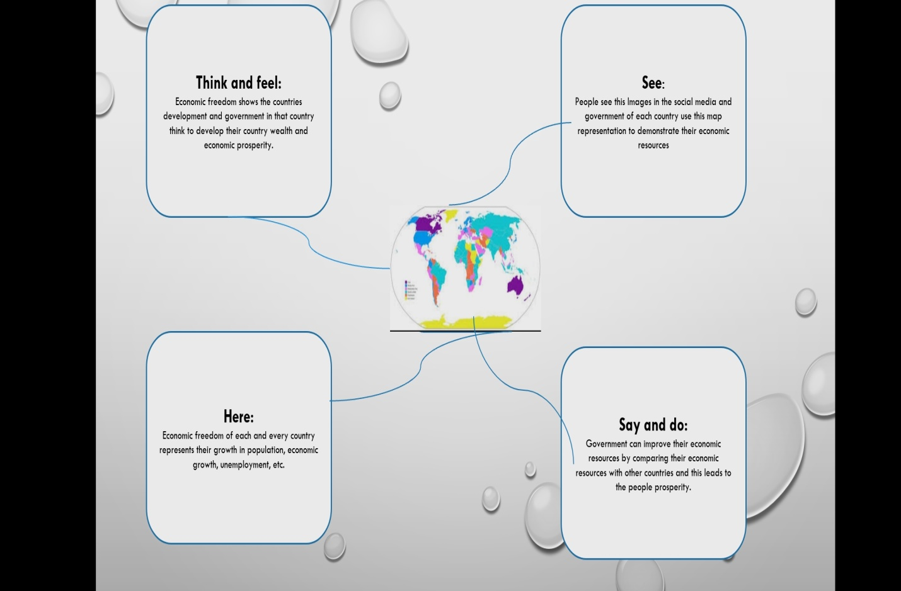

* 1. Ideation and brainstorming map

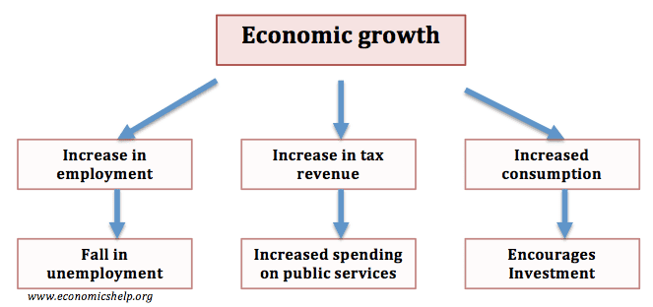

1. Results

Dashboard

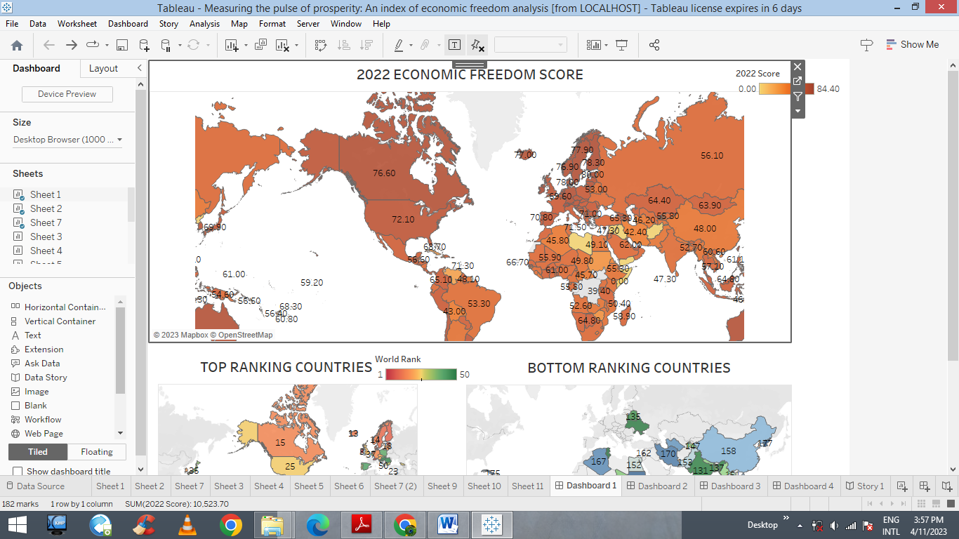

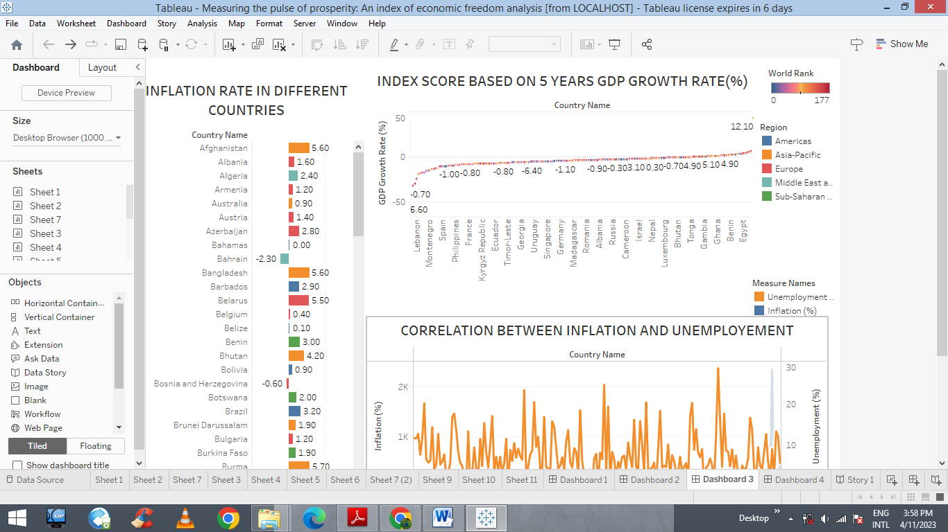



story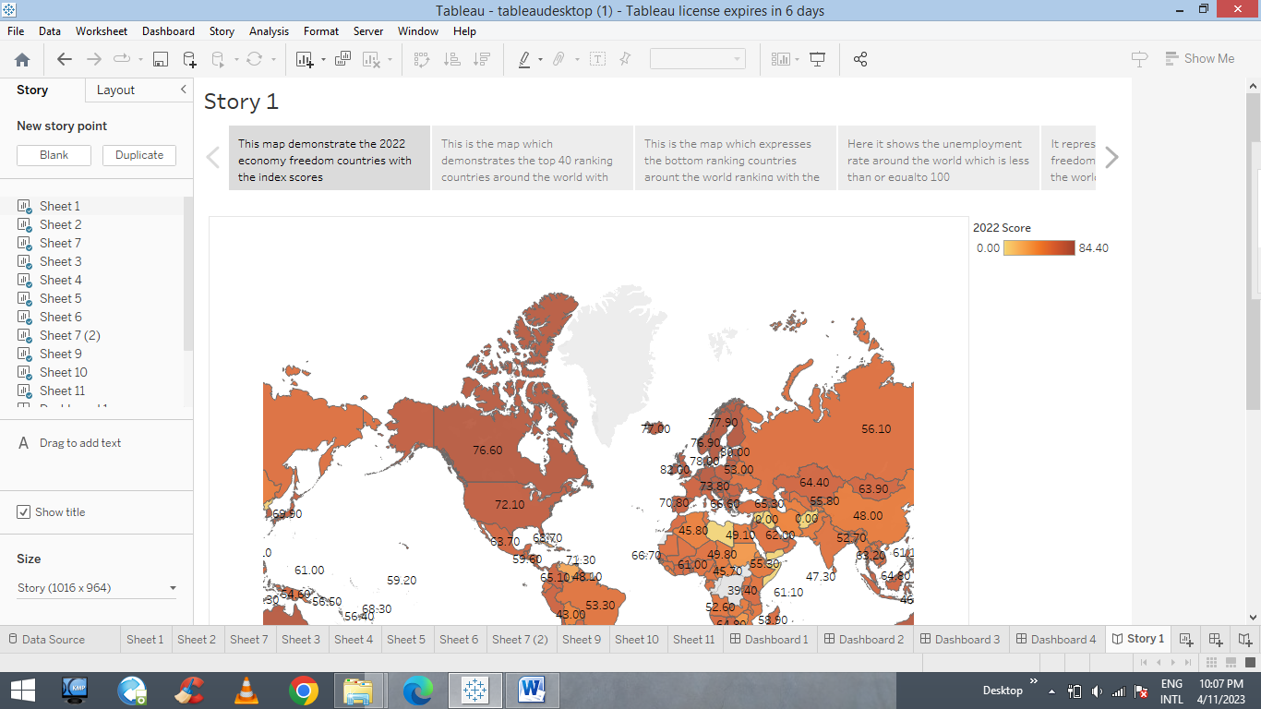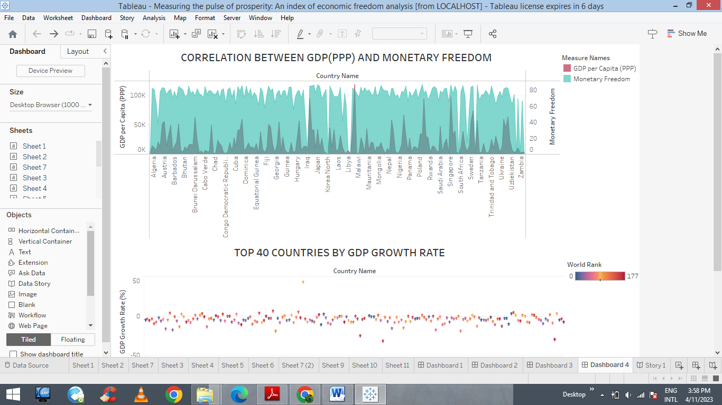

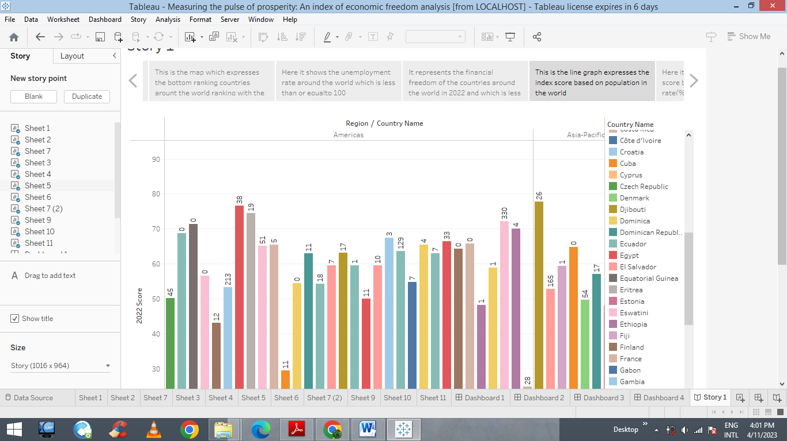

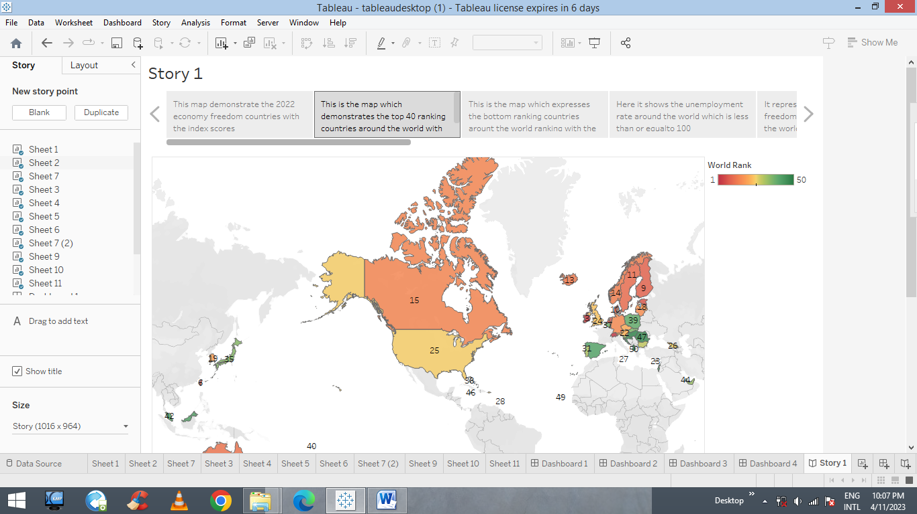

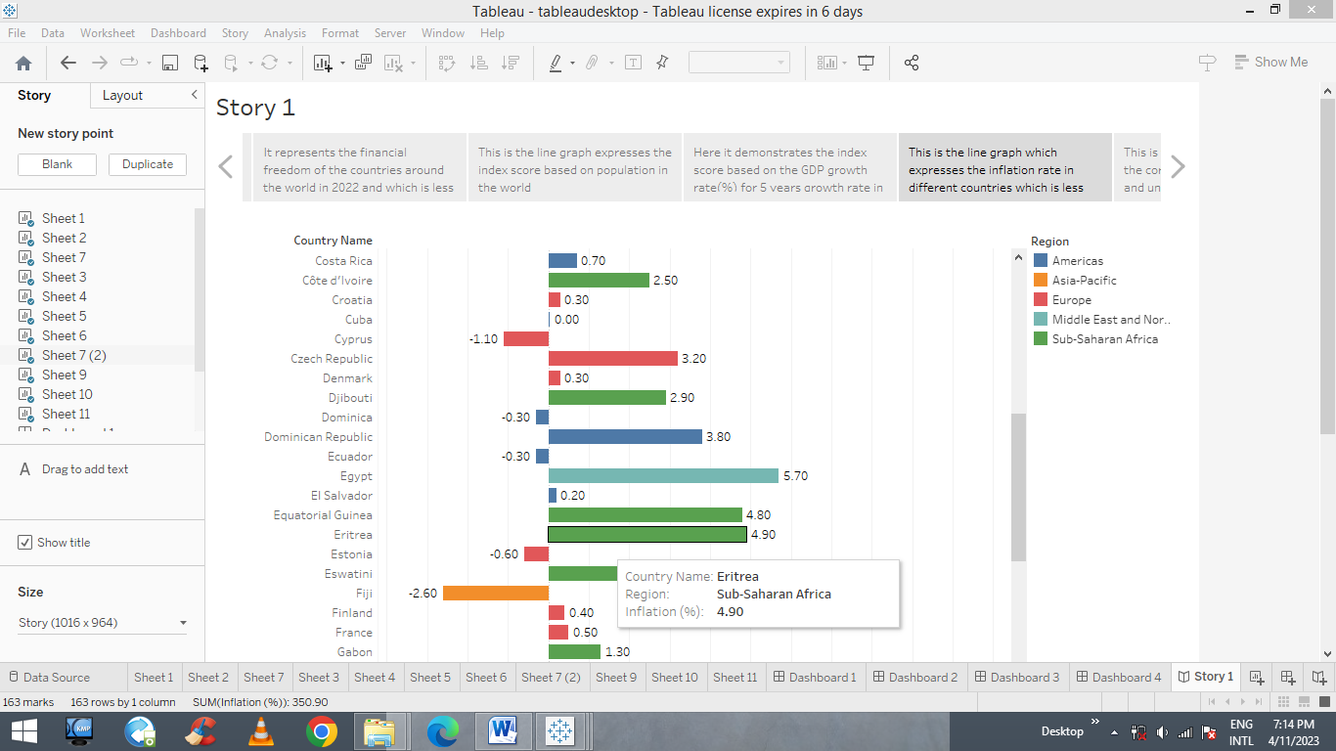

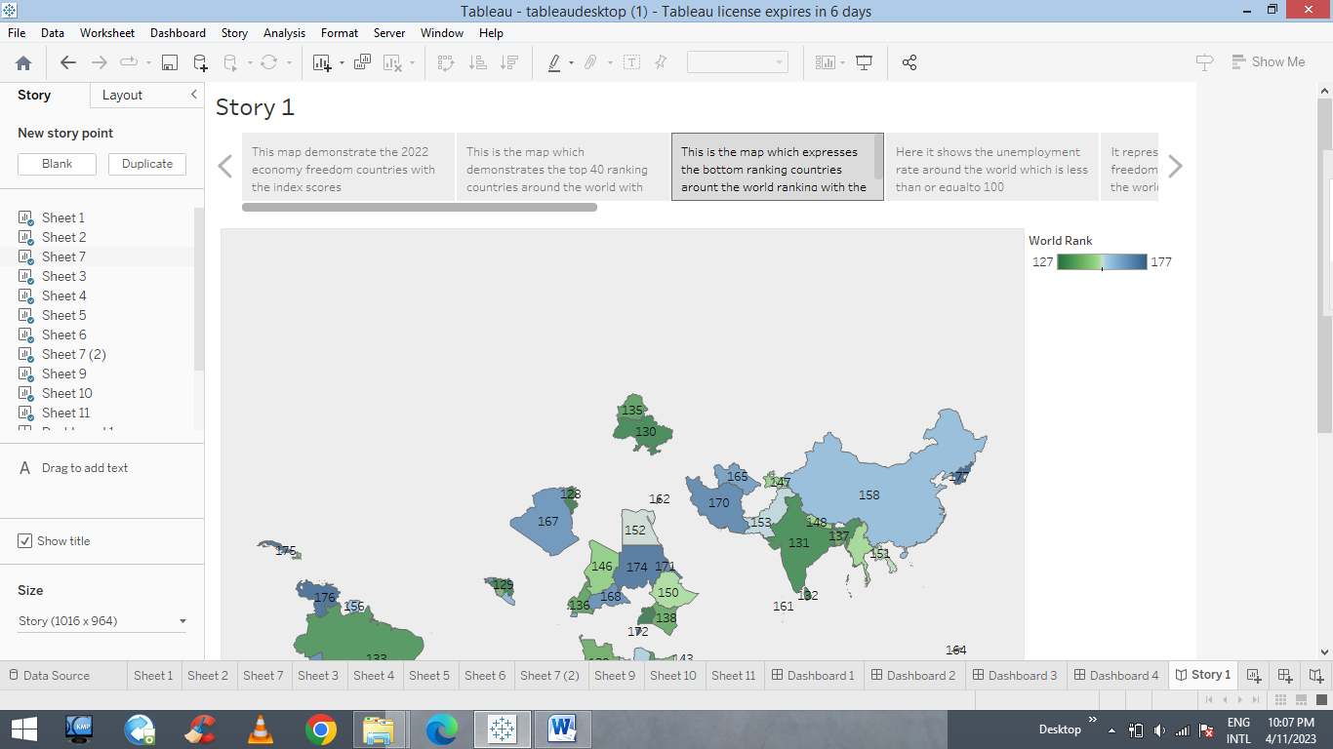

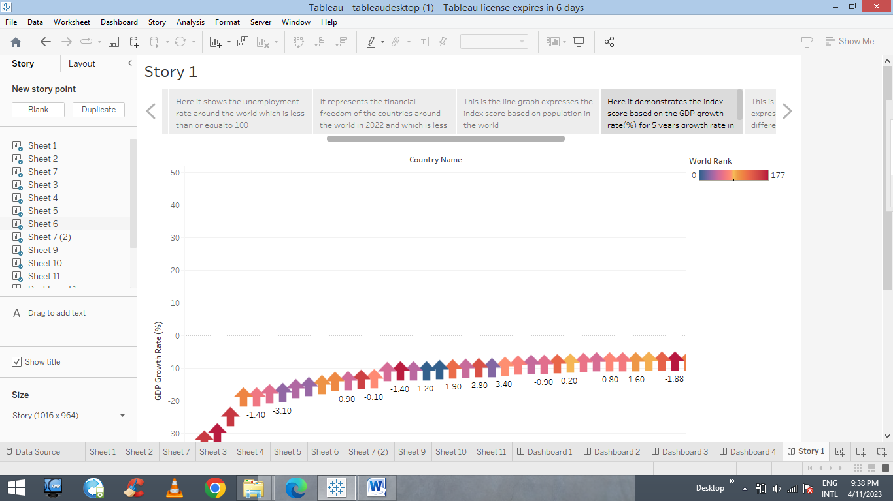

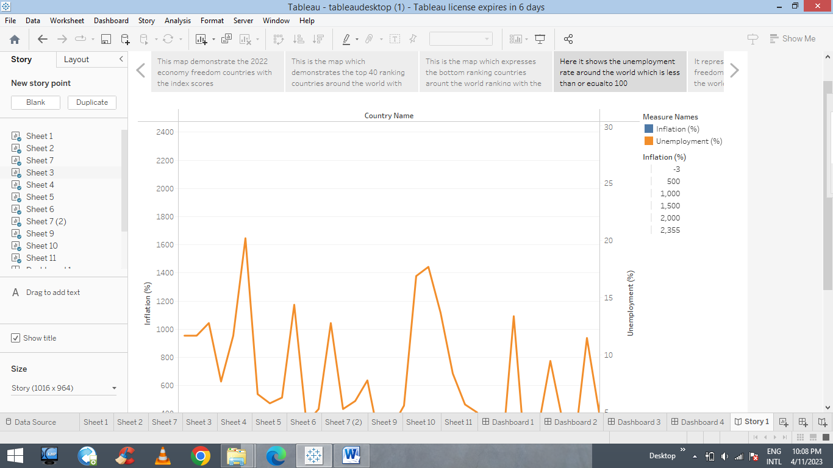

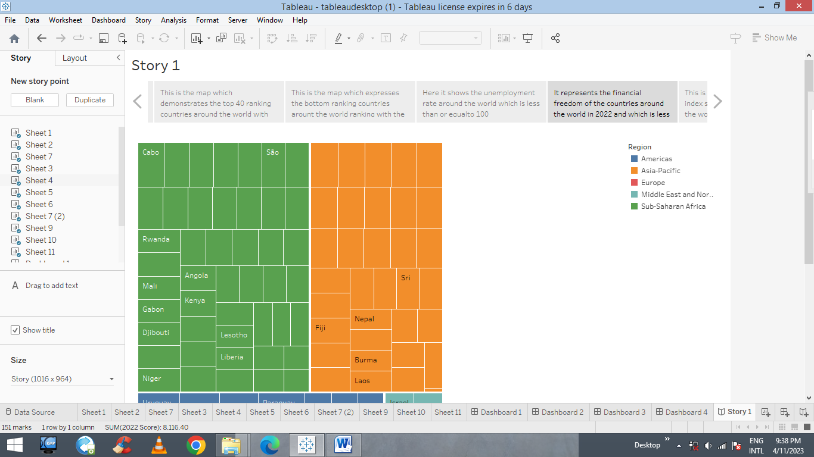

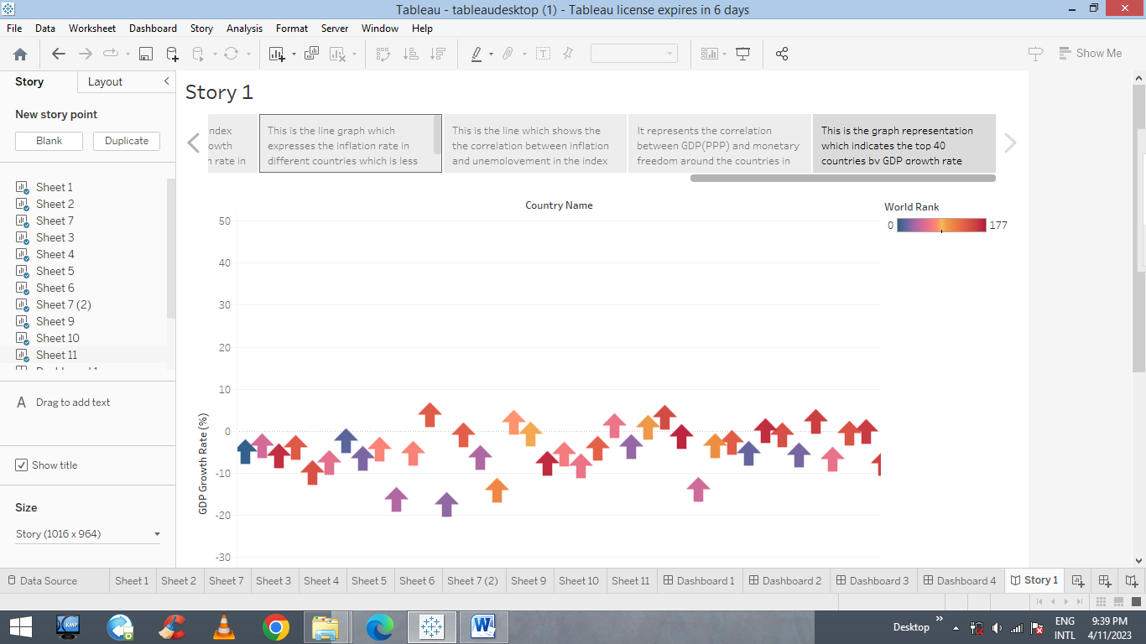

1. Advantages and disadvantages

* Advantages:
* The index of economic freedom project shows the economic growth of every country is improving and also reducing.
* Economic growth enables costumers to consume more goods and services and enjoying better standard of life.
* This economic freedom may also reduce unemployment and poverty, increases life expectancy, improve government finance, etc.
* Tableau can handle large amount of data, and also mobile supports all the features in the tableau.
* By data analytics detects and correct the errors from data sets with the help of data cleaning. Thus helping to improving quality of the data and it removes the duplicate information from the data set and hence saves large amount of memory space.
* Disadvantages:
* The main process in the project in the title of index of economic freedom is to measure the economic growth of countries around the world.
* This economic growth include inflation, unemployment, etc. this is the big drawback.
* The cost of data analytics tools vary based on different applications and features support.
* An index of economic freedom analysis includes the disadvantages such as no government intervention, unemployment, poor working condition.

Application:

An index of economic freedom is a composite measure of quality of political-economic institution across different jurisdictions. Investors can use the index economic freedom as a quick way to monitor the changes in economics where they are interested in exposure. These indexes are motivated by the economies that are more rapid growth, and higher average incomes. This promoting economic opportunity, individual empowerment & prosperity. This index of economic freedom analysis used by many countries to identify there growth rate, economic growth, and to find unemployment, etc. by comparing this the countries improving the growth rate and there prosperities.

Data analytics is the science of analyzing raw data to make conclusions about that information. It includes the structuring of a massive amount of irregular data and derive the useful required information from these using statistical tools. It all involves the preparation of chart, graph, etc. Data analytics helps a business optimize its performance, perform more efficiently, maximize profit, or make more strategically-guide decisions. The data analytics that are being use across the world: security, manufacturing, transport, risk management, delivery, healthcare, education, travel, military, insurance, digital advertisement, communication, media and entertainment, internet, economic index, etc.

1. Conclusion

By the measuring the pulse prosperity: an index of freedom analysis I have conclude that this data analytics will improve the countries wealth and also it may decrease too. From this project economic growth of a country will not have a rapid growth its improving slowly and by this growth the country becomes the top most country in the index. Data analytics gives be a knowledge to understand the data collection easily by using chart or graph, etc. This visualization is also helps to comparing countries to find there economic growth, unemployment, monetary freedom levels and to develop there nations.

1. Future scope

*Economic freedom is the fundamental right of every human to control his or her own labor and property*

Economic freedom will help to improve their economic level and prosperity level. Economic freedom has pointed out some important correlations that should encourage nations to try to improve their scores over time. The most is the observation that people living in countries categorized as free or mostly free enjoy higher incomes than those living in lower scoring nations.

The growth of data analytics is supporting the data analytics industry with a great increase in the amount of data collection which can be used to tap into several different sectors in the market.